Mon & Tues. 8:00 AM – 6:00 PM  Wed-Fri. 8:00 AM – 5:00 PM  Amber Jackson  Breastfeeding Peer Counselor  For WIC Clients 316-665-1812, 24/7  Facebook: HarveyCounty BFPC  Alice Jantzen, RN, BSN  Lactation Consultant  Private lactation visits can be scheduled, $35, free for WIC Clients  Third Trimester WIC Support Group (Emphasis on Coffective)  Every 1st Monday of the month at 4pm and 3rd Monday at 11am. |  | Maternal and Child Program  Breast pump Loan Program-Breast pumps for WIC clients or sliding fee scale for the general public (non-WIC clients).  Walk-In Weight Checks at Health Department during office hours, free of charge.
La Leche League  Newton  Meetings to give support and help answer your questions about breastfeeding women, infants, and children are welcome. Text La Leche League for breastfeeding advice: Pat Olson 316-727-2231 or Marcia Hahn 620-327-2231, Text 620-217-1280.  Check La Leche League Newton Facebook Group for meeting dates and times or or Instant Message.  State website:  www.kansaslll.org |  |  | 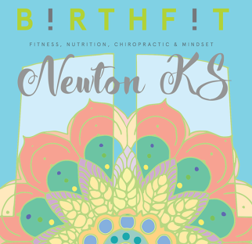  Sway_Harvey –Motherhood Support Program  Mallorie Coffman, DC  Facebook: Sway Harvey  Connected Moms on Tuesdays/Fridays (on FaceBook)  Instagram: Sway_Harvey
Look for local businesses with this logo in their  windows, and feel welcome to breastfeed there.  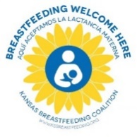  Breastfeeding Helpline:  Some examples of popular and informative websites are:  www.womenshealth.gov/breastfeeding/  Kansas La Leche League  www.workandpump.com  https://medlineplus.gov/breastfeeding  (English or Spanish)  Kelly Mom  Kansas Breastfeeding Coalition  www.kansasbusinesscase.com  ---------------------------------------------------------------  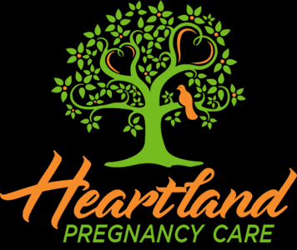  Heartland Pregnancy Care Center  1025 S. Washington Rd, Ste. C, Newton  316-283-7333  info@heartlandpcc.com  www.heartlandpcc.com | Kansas Children’s Service League  Healthy Families Harvey County  215 S. Pine St., #314, Newton 316-333-1888 x1942  vschwiethale@kcsl.org www.kcsl.org  Google Searching?  Use reliable websites to get your information.  - Who is the author and what are their credentials? Are they an experienced teacher or coach?  - Who published the site? Domain names ending in .edu (educational) or .gov (government) or .org (non-profit) are more reliable.  - What is the main purpose of the site? Are they selling a product or is this a public service?  - Who is the intended audience?  - What’s the quality of information? Is the information old and outdated, new or time-tested?  - Does the information contradict information from La Leche League or your Certified Local Lactation Consultant?  ------------------------------------------------------------------------------  The larger community can help too!  Stanford University Recommendations- Express milk frequently in the first 3-4 days. Learn manual expression.  Watch their video  http://newborns.stanford.edu/Breastfeeding/HandExpression.html  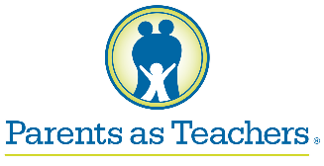  PARENTS AS TEACHERS  316-284-6510  816 Oak Street, Newton  Free parenting support and helps you understand child development. Harvey County PAT is for any family living in Newton (USD 373), Sedgwick (USD 439), Halstead/Bentley (USD 440), and Hesston (USD 460) school districts with children pregnancy to school entry.

